FASHION DEMAND FORECASTING USING MACHINE LEARNING AND DOMAIN ADAPTATION
Methodology, Novelty and Key Contributions
Department of Computer Science and Engineering, TKR College of Engineering & Technology
Batch A17 (CSE-A) · Academic year [ACADEMIC YEAR]
Table 1: Project team
S.No. | Student name | Roll number
1 | B Shilpa | 23K91A0547
2 | B Hari Narayana | 23K91A0544
3 | A Rani Thejaswini | 23K91A0516
4 | A Sanjana | 23K91A0511

Project guide: Deepthi
Chapter and section numbers quoted in the text (for example Chapter 8 or Section 6.2) refer to the full project report, 17.Final Document. Figures and tables in this document are numbered from 1.

1. METHODOLOGY
This document describes how TrendCast works from end to end and what is new in it. Part 1 gives the pipeline, the data, the algorithms and the reasons they were chosen; Part 2 sets the work against the base paper and separates what is new from what is standard; Part 3 lists the contributions.

1.1 Overall methodology
TrendCast treats demand forecasting as a supervised regression on a daily panel: one row per article per day, with the number of units sold as the target. The base paper [1] follows the same recipe with LightGBM on the UCI Online Retail II data and adds four layers of explanation; TrendCast keeps the recipe, uses XGBoost [2] as the batch abstract specifies, and adds the step the base paper leaves out: moving a trained model between differently distributed parts of the business. The method has eight steps.
1. Ingest. Read the transactions and articles files (customers optional), check that the required columns exist and stop with a plain message if they do not.
2. Clean and merge. Parse dates, remove unusable rows, left-join the product attributes so that no sale is lost because a catalogue entry is missing.
3. Aggregate. Count the transactions of each article on each day (the demand), average the price, take the most frequent sales channel, and fill the days without a sale with zero.
4. Engineer features. Add calendar, cyclical, lag, rolling and encoded attribute features, all computed only from the past.
5. Split by date. The earliest 80 % of the dates train the model, the latest 20 % test it; tuning uses time-ordered folds.
6. Fit and compare. Fit the moving-average baseline and XGBoost (optionally tuned) and report RMSE, MAE, safe MAPE and R2.
7. Adapt across domains. Choose a domain column, a source value and a target value; train on the source, test on the later half of the target, estimate importance weights with a domain classifier, retrain with the weights and report the change.
8. Forecast and explain. Roll the model forward 7, 14 or 30 days, show gain-based feature importance, and optionally ask Gemini to put the numbers in words.
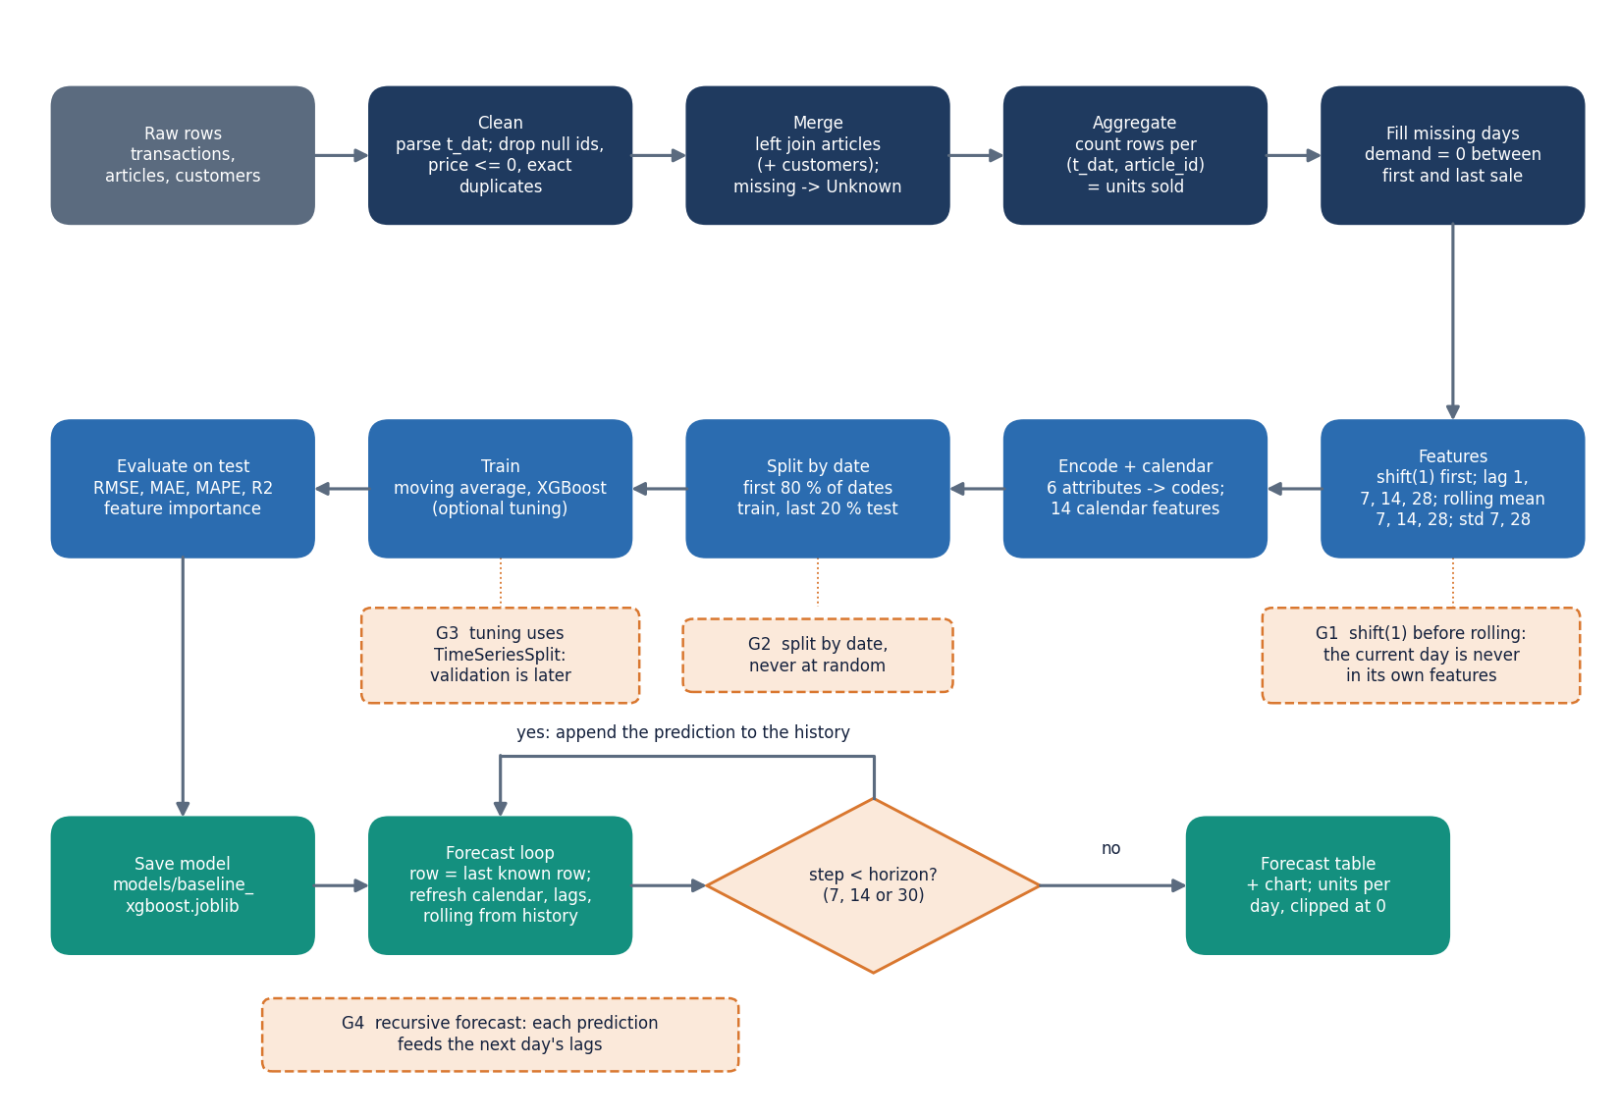
Figure 1: Flowchart of the core algorithm: from raw transactions to the recursive forecast, with the leakage guards marked.

1.2 Dataset
All measurements use the H&M Personalized Fashion Recommendations data [23]: 31,788,324 transactions, 105,542 articles and 1,371,980 customers according to the dataset card of the parquet mirror we downloaded. The files are used under the competition's academic terms and are not redistributed in the repository. Because the whole file is too large for the machine used (15.7 GB of memory, no GPU), we took the first transaction shard (4,541,190 rows from 2018-09-20 to 2019-01-04, 42,415 articles) and kept the 300 best-selling articles with all of their transactions: 684,392 rows over 2018-09-20 to 2019-01-04 (107 days), 276,168 customers. scripts/make_real_subset.py rebuilds this subset in the exact CSV schema the application expects.
Table 2: The real subset used for every reported number.
Quantity | Value
Transaction rows read | 684,392
Rows after cleaning | 605,178 (79,214 exact duplicates removed, 11.6 %)
Articles / customers | 300 / 276,168
Date range | 2018-09-20 to 2019-01-04 (107 days)
Rows per channel (cleaned) | channel 1: 227,131; channel 2: 378,047
Article-days with a sale | 30,481
Modelling rows after zero-filling | 31,094 (1.97 % zero demand)
Model inputs | 31
Chronological split | train 24579 rows (to 2018-12-13), test 6515 rows (2018-12-14 to 2019-01-04)

Three properties of this subset shape every result. It covers only 107 days, so no yearly seasonality can be learned; the test window contains the Christmas peak and the January sales, which the training window has never seen. It contains the best-selling articles, so zero-demand days are rare (2 %), whereas the full catalogue is intermittent. And the two sales channels are coded 1 and 2 in the files without a name; we call them channel 1 and channel 2 and use 'store' and 'online' in a few labels only as our own convention, which the data do not state. A synthetic file in the same schema (data/sample_hm, 90 articles) ships for smoke tests; no reported metric uses it.

1.3 Preprocessing
Preprocessing is implemented in src/preprocessing.py and src/demand_forecasting.py and is applied identically in the web application, the Streamlit application and the experiment script.

1.3.1 Cleaning and merging
clean_transactions parses t_dat to a date (invalid dates become missing), drops rows without a date, article id or customer id, keeps only rows with a positive numeric price, removes exact duplicate rows and sorts by date. clean_articles fills missing text attributes with Unknown rather than dropping the product, and clean_customers fills a missing age with the median. merge_datasets left-joins articles (and customers) onto the transactions, so a transaction whose article is absent from the catalogue survives with Unknown attributes. The data-quality report counts rows read and kept, missing values, duplicates, customers, products and the date range; the upload page shows it.
One cleaning rule deserves a warning. Removing exact duplicates dropped 79,214 rows (11.6 %) of the subset. In the H&M file a repeated identical row is usually a customer buying two units of the same article on the same day, so the rule understates demand slightly and flattens the largest days. We kept the rule because it is part of the shipped pipeline and applied it in every experiment; Chapter 9 lists it among the limitations.

1.3.2 From transactions to daily demand
aggregate_daily_demand groups the cleaned rows by date and article. The demand is the number of rows, since each row is one unit sold; the price is the mean price of that day; the sales channel is the most frequent channel of that day; and the article's descriptive attributes are carried along from the first non-null value. fill_missing_dates_per_article then re-indexes each article onto a continuous daily range between its first and last sale, sets the missing demand to zero and forward- and back-fills price, channel and attributes. Articles with fewer than five sale-days are skipped by this function and therefore leave the modelling table; none of the 300 subset articles is affected.
Two consequences follow from using the day's mean price and modal channel. Both are computed from the very transactions that make up the target, so they are not strictly known before the day, and on a zero-demand day they are copied from a neighbouring day. We treat price as a planned input and report this as a limitation rather than silently excluding it; the ablation in Section 6.5 shows what it is worth. The channel is also a mixture: demand counts units from both channels, while the label is only the day's majority channel.

1.4 Feature engineering
build_feature_table produces the 31 model inputs in four groups. The calendar, lag and rolling groups follow the same temporal-integrity rule as the base paper [1]: a feature of day t may use only information from day t-1 and earlier.
Table 3: The 31 model inputs.
Group | Inputs | Count
Price and channel | price, sales_channel_id | 2
Product attributes (label-encoded) | product_type, product_group, colour_group, department, section, garment_group | 6
Calendar | year, month, day, day_of_week, week_of_year, day_of_year, quarter, is_weekend, is_month_start, is_month_end, month_sin, month_cos, dow_sin, dow_cos | 14
Lag and rolling (past demand of the same article) | lag_1, lag_7, lag_14, lag_28, rolling_mean_7/14/28, rolling_std_7/28 | 9

Cyclical encoding. Month and weekday are also given as a sine and cosine pair so that December and January, or Sunday and Monday, are neighbours; a tree model cannot infer this from the raw integer. Lags. lag_k is the article's demand k days earlier, computed with groupby(article).shift(k). Rolling statistics. The demand is shifted by one day first and the window is applied afterwards, so the current day never enters its own mean or standard deviation. Rows without enough history take the value 0, which a tree reads as 'nothing observed'. Attributes. Text attributes are converted to integer codes with a stored mapping (one-hot would create hundreds of columns for the department and colour fields), which treats the codes as ordered numbers; trees cope with this, but the codes carry no meaning in themselves.
The domain-adaptation route removes the chosen domain column from this list, so a model or classifier cannot read the domain from a feature. The same list, saved as models/feature_info.joblib, is used to rebuild the input of a loaded model.

1.5 Algorithm choice and justification
The batch abstract names XGBoost as the learner, and the choice is easy to defend on engineering grounds: it handles mixed numeric and encoded features without scaling, trains in about a second on this table, has regularisation built in [2] and, decisively for this project, accepts a per-row sample_weight, which is the entry point for domain adaptation. Gradient boosting [8] also matched or beat deep learning in the M5 retail competition when given engineered features [6], which is the base paper's argument for its own choice.
Whether it is also the most accurate choice on our data is a separate, measured question. All learners below use the same 31 inputs and the same 80/20 split; the first four rows need no training.
Table 4: Model comparison on the real subset (test window 2018-12-14 to 2019-01-04, 6,515 rows).
Model | RMSE | MAE | R2 | WAPE %
Moving average (7d) | 12.891 | 8.090 | 0.101 | 65.3
Naive (lag 1) | 9.225 | 5.651 | 0.540 | 45.6
Seasonal naive (lag 7) | 12.032 | 7.293 | 0.217 | 58.9
Rolling mean 7 (shifted) | 9.307 | 5.653 | 0.531 | 45.6
Random forest | 13.258 | 7.527 | 0.049 | 60.8
LightGBM | 10.060 | 6.706 | 0.452 | 54.1
XGBoost (default, 5 seeds) | 11.089 | 7.077 | 0.335 | 57.1
XGBoost (tuned, 10 iters x 3 TS-CV) | 10.341 | 6.881 | 0.421 | 55.6

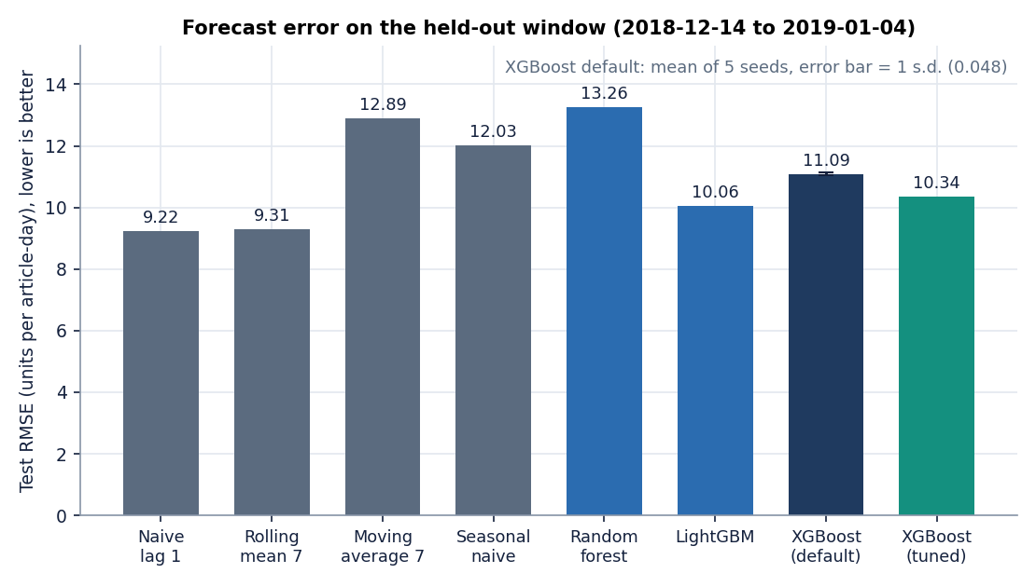
Figure 2: Test RMSE of every forecaster on the real H&M subset (XGBoost default: mean of five seeds with standard deviation).
Three readings follow. Gradient boosting beats the product's own baseline: XGBoost reaches RMSE 11.09 against 12.89 for the 7-day moving average, and 10.34 when tuned. Seed noise is small (RMSE 11.089 ± 0.048 over five seeds), so differences of more than about 0.1 are real. A one-line baseline is better still: repeating yesterday's demand gives RMSE 9.22 and the shifted 7-day mean 9.31. The base paper reports the same ordering of difficulty: its LightGBM beats a 7-day moving average by 2.86 RMSE but its naive lag-1 baseline is far worse on its much more intermittent SKU data [1]. On our best-selling articles, demand is smooth enough that yesterday is a strong predictor.
The ablation explains why. We refit XGBoost with groups of features removed (three seeds each).
Table 5: Feature-group ablation (XGBoost default, mean of three seeds).
Feature set | Inputs | RMSE | R2 | WAPE %
all features (as shipped) | 31 | 11.056 | 0.339 | 57.0
no lag / rolling | 22 | 16.161 | -0.413 | 89.6
no price, no channel | 29 | 11.438 | 0.292 | 58.4
no product attributes | 25 | 11.213 | 0.320 | 55.0
calendar only | 14 | 15.178 | -0.247 | 93.6
lag / rolling only | 9 | 9.403 | 0.522 | 47.4
lag / rolling + price | 10 | 9.672 | 0.494 | 47.1

The lag and rolling features carry the model: without them R2 falls to -0.41, and calendar features alone are worse than predicting the mean of the test window. The most striking row is the last but one: a model that uses only the nine lag and rolling inputs (RMSE 9.40) is better than the shipped 31-input model (RMSE 11.06). The extra inputs include absolute-time features (year, quarter, day_of_year, month) whose test values lie beyond the training range; a tree can only predict the value of the last leaf it has seen for them. This agrees with the base paper's ablation, in which rolling statistics were the dominant group. We kept the shipped feature set for the product because changing it was outside the scope of a documentation run, and we report the better variant as a finding in Chapter 8.
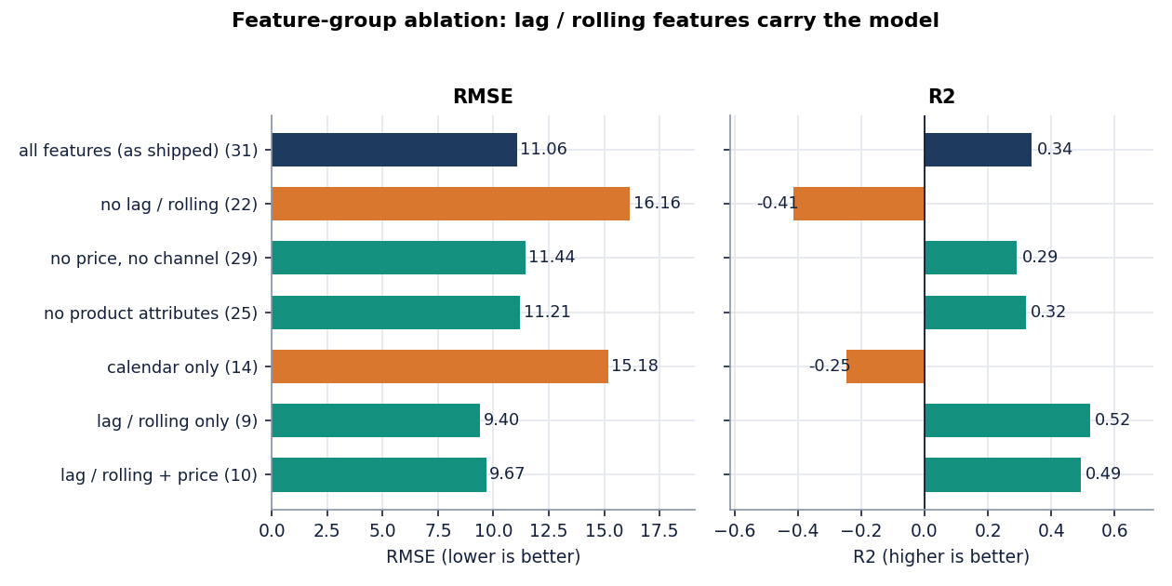
Figure 3: Feature-group ablation: lag and rolling inputs carry the forecast; the calendar group alone is not enough.

1.6 Mathematical formulation

1.6.1 Features
Let y(a, t) be the units of article a on day t. The lag, rolling and cyclical features are
lag_k(a, t) = y(a, t - k), k in {1, 7, 14, 28} (1)
rolling_mean_w(a, t) = (1/w) * sum_{i=1..w} y(a, t - i), w in {7, 14, 28} (2)
month_sin = sin(2*pi*month/12), month_cos = cos(2*pi*month/12), dow_sin = sin(2*pi*dow/7), dow_cos = cos(2*pi*dow/7) (3)
The rolling standard deviation uses the same window over the shifted series (windows 7 and 28). Because every sum starts at i = 1, y(a, t) never appears in its own features.

1.6.2 The XGBoost objective
XGBoost [2] builds an additive ensemble of K regression trees, y_hat = sum_k f_k(x), by minimising a regularised squared-error objective. With per-row weights w_i, as used for domain adaptation, the objective is
L = sum_i w_i * (y_i - y_hat_i)^2 + sum_k [ gamma * T_k + (lambda/2) * ||v_k||^2 ] (4)
where T_k is the number of leaves of tree k and v_k its leaf values (library defaults gamma = 0 and lambda = 1). For squared error the second derivative of each row's loss is proportional to w_i, so the sum of the second derivatives in a candidate leaf is the sum of the weights in it. XGBoost refuses a split whose child has a derivative sum below min_child_weight, which is 1 by default. This detail looks technical but it decides what happens when the weights are tiny (Section 6.8).

1.6.3 Importance weights for covariate shift
Under covariate shift the inputs have different densities in the source (p_S) and target (p_T) domains but the relation between inputs and demand is the same. Training on the source with each row weighted by w(x) = p_T(x) / p_S(x) then minimises the target risk [10]. The ratio is not estimated directly. A classifier is trained to tell source rows (label 0) from target rows (label 1) [12]; by Bayes' rule its output p(x) = P(target | x) satisfies
p(x) / (1 - p(x)) = [ p_T(x) / p_S(x) ] * [ n_T / n_S ] (5)
where n_S and n_T are the numbers of source and target rows the classifier saw. TrendCast uses the odds themselves as the weight, clipped to avoid a few dominating rows:
w(x) = min( p(x) / (1 - p(x)), 20 ), with p clipped to [1e-6, 1 - 1e-6] (6)
The odds therefore equal the density ratio times n_T / n_S: the weights are not normalised to a mean of one. This is visible in the data: for the pair channel 2 to channel 1 the mean weight was 0.648 and n_T / n_S = 12,240 / 18,854 = 0.649. When the two classes are of similar size the factor is harmless; when the classifier separates the domains perfectly the odds become tiny and the factor no longer matters, because the weights are tiny anyway.

1.6.4 Metrics
RMSE = sqrt( (1/n) * sum (y_i - y_hat_i)^2 ), MAE = (1/n) * sum |y_i - y_hat_i| (7)
safe-MAPE = (100/m) * sum_{y_i != 0} |y_i - y_hat_i| / |y_i|, R2 = 1 - sum (y_i - y_hat_i)^2 / sum (y_i - mean(y))^2 (8)
Safe MAPE skips the rows with zero demand (there are 345 in the test window) and reports their number. Even so it is very large here (about 140 %) because low-volume days dominate a ratio of errors, so it is a poor guide on its own and we add the weighted absolute percentage error WAPE = sum|y - y_hat| / sum y (offline), which divides by total units and is stable [9]. The improvement from adaptation is (before - after) / before for the error metrics, so a negative value means the adapted model is worse.

1.7 Model architecture and training
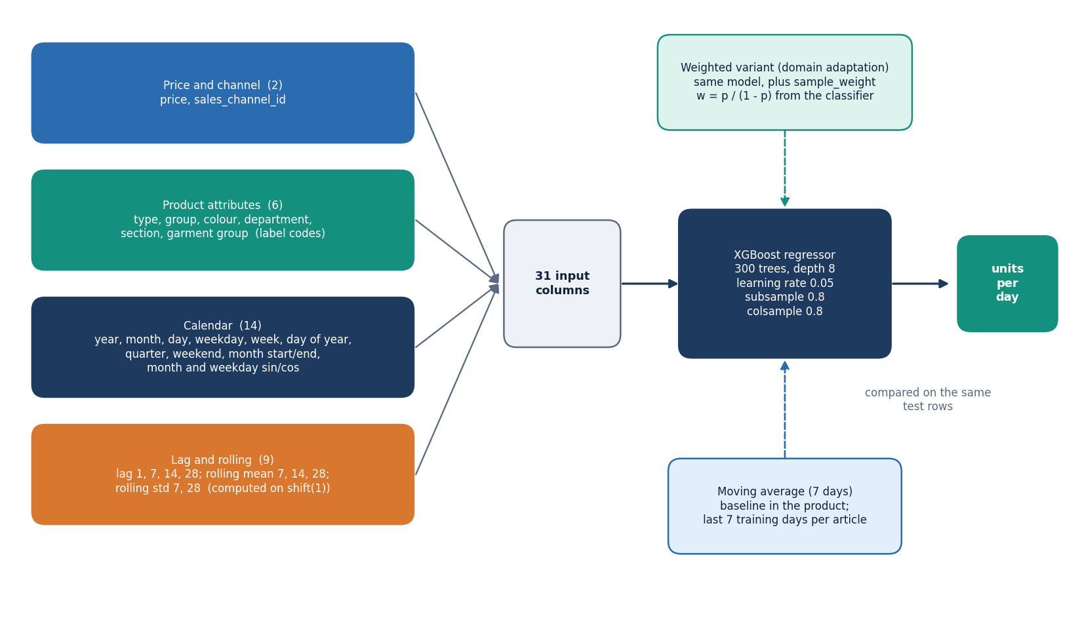
Figure 4: Model architecture: 31 input features in four groups feeding one XGBoost regressor, with the baselines and the weighted variant.
The model is a single XGBRegressor. Its defaults, set in xgboost_model.DEFAULT_PARAMS, are 300 trees, depth 8, learning rate 0.05, row and column subsampling of 0.8, squared-error objective and random state 42. On this table a fit takes 1.9 s and a prediction 2.3 microseconds per row on the CPU.
Tuning is optional. tune_xgboost runs RandomizedSearchCV [25] over six parameters (n_estimators 100-500, max_depth 4-12, learning_rate 0.01-0.2, subsample and colsample_bytree 0.6-1.0, min_child_weight 1-7), with ten sampled settings, three TimeSeriesSplit folds (each validation fold lies after its training fold) and negative RMSE as the score; scikit-learn [24] supplies the search. The tuned model chose 400 trees of depth 12, learning rate 0.01, subsample 0.7, column sample 0.6 and min_child_weight 5; the search took 31 s and improved the test RMSE from 11.09 to 10.34. The training page shows the winning parameters.
Baselines. The moving average predicts each test row with the article's mean over the last seven training days, falling back to the article mean and then the global mean. A random forest (200 trees, depth 10) and LightGBM (300 trees, depth 8) are available as optional comparators. The trained default model is saved to models/baseline_xgboost.joblib together with its feature list.

1.8 Domain adaptation procedure
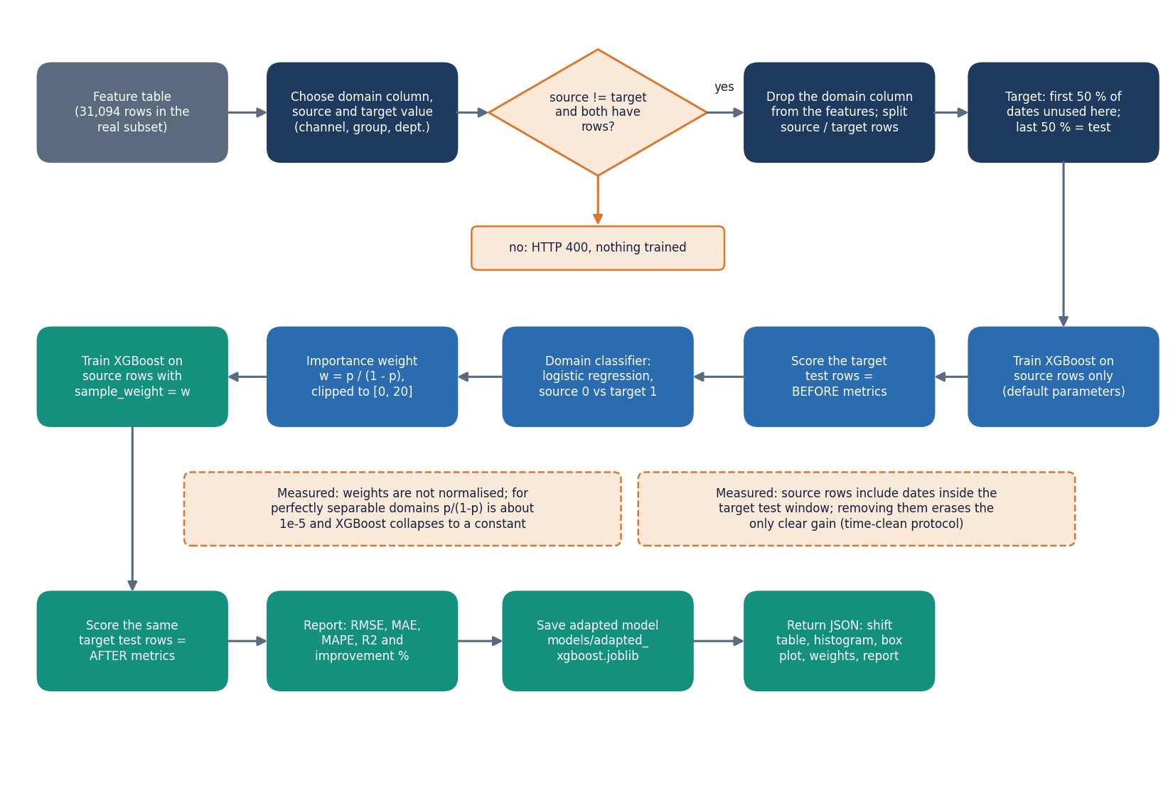
Figure 5: Flowchart of importance-weighted domain adaptation as implemented in domain_adaptation.py and the /api/domain/run route.
The procedure is implemented in backend/main.py::run_domain using the functions of src/domain_adaptation.py. The analyst chooses one of three domain columns (sales channel, product group, department) and two different values. The steps are:
1. Remove the domain column from the model inputs. Split the feature table into source rows (all dates) and target rows.
2. Hold out the later half of the target dates as the test set; the earlier half is not used for fitting in the product.
3. Train XGBoost on the source rows only and score the target test rows: the before metrics.
4. Fit a logistic regression that separates source from target rows (25 % of the stacked rows are held out to report its accuracy; the accuracy measures how different the domains are). The target rows given to the classifier include the test dates, but only their inputs, never their demand.
5. Compute the importance weight of each source row as p / (1 - p), clipped to [0, 20].
6. Retrain XGBoost on the source rows with those weights and score the same test rows: the after metrics. Save the model and report the change in RMSE, MAE, MAPE and R2.
The experiments of Chapter 8 repeat this procedure for six source-target pairs with five XGBoost seeds each and add controls that the product does not have: a target-only model trained on the first half of the target; a pooled model trained on the source plus the first half of the target without weights; the same weights shuffled randomly; the weights rescaled to a mean of one; and a 'time-clean' variant in which the source rows are limited to dates before the target test window.
Reading the procedure against the controls produced two implementation findings that we report as facts. First, the source model is trained on dates that overlap the target test window; for the channel pair the gain of +11.9 % turned into -2.8 % when the overlap was removed. Second, the weights are not normalised: for the department pair Knitwear to Trouser the classifier is perfectly accurate, the mean weight is 5.1e-05, no split can reach min_child_weight = 1 (Section 6.6.2), XGBoost stops splitting and predicts a constant, and the RMSE gets 46 % worse. Rescaling the same weights to a mean of one removed the collapse. Logistic regression is also fitted to unscaled features and does not reach convergence within 1,000 iterations, which scikit-learn reports as a warning on every run. None of these was changed in the product during this documentation; Chapter 8 gives the measurements and Chapter 10 the fixes.
Figure 6: Model and feature architecture of TrendCast.
Figure 7: Flowchart of the core algorithm, with the leakage guards marked.

2. NOVELTY AGAINST THE BASE PAPER

2.1 What the base paper contributes
The base paper [1] pairs a LightGBM demand model with a four-level explainability pipeline: permutation importance, partial dependence, SHAP and individual conditional expectation (ICE) curves. It is validated on the UCI Online Retail II data (1.07 million transactions, 4,631 products, 41 engineered features, one-day-ahead forecasts) and reports RMSE 33.71 and R2 0.243, with paired significance tests against six baselines. Its own ablation finds that rolling statistics are the dominant feature group, and its limitations section names single-dataset validation, a stationary-relationship assumption and one-step forecasts. It does not address transfer to a differently distributed market, new products or domain shift.

2.2 What is new in TrendCast
• A domain-adaptation workflow on top of gradient boosting. The batch gap is that a model trained in one retail context should transfer to a new one. TrendCast adds an importance-weighted step (a logistic domain classifier gives each source row the weight p/(1-p), clipped at 20) to a gradient-boosted demand model, with a shift table, the classifier accuracy, weight statistics and a before-and-after report on screen. The technique itself is the covariate-shift weighting of Shimodaira and Bickel et al. [10], [12]; what is new is its inspectable use inside a demand-forecasting product.
• A gated, tested web console. The original Streamlit script was wrapped in a FastAPI service with 22 routes and a 13-page React console in which every page refuses to run until the earlier step is done, validation errors are explained in plain language, and 39 pytest tests plus a 26-check smoke test cover the pipeline and the API.
• Controls that test the adaptation honestly. Besides the before-and-after pair the evaluation harness trains a target-only oracle, a pooled source-plus-target model, a shuffled-weights control, a mean-1 rescaling of the weights and a time-clean protocol. These controls are what exposed that the one clear gain came from time overlap and that degenerate weights collapse XGBoost.
• A like-for-like baseline set. Naive lag-1, a seven-day moving average, a shifted rolling mean, random forest and LightGBM are scored on the same split as XGBoost, because the base paper's own baselines showed how strong naive lag-1 can be.

2.3 What is standard
XGBoost [2], gradient boosting [8], random forests [7], calendar and lag features, chronological splitting, TimeSeriesSplit tuning and random search [25] are established techniques used as they are. Gain importance is the library's default; TreeSHAP [5] was used only offline through XGBoost's built-in contributions. The importance-weighting idea is from the covariate-shift literature.

2.4 What the base paper has and TrendCast does not
• No ICE, PDP or permutation-importance layers. The app shows gain importance for the top 20 features; exact SHAP values were computed offline and agree only moderately with gain (Spearman 0.40). There is no per-forecast explanation in the product.
• No statistical significance tests or Optuna tuning. TrendCast reports five-seed means with standard deviations and a ten-iteration random search.
• No external validation set. One 107-day window of one retailer was measured, so even the ranking of models is specific to that window; the base paper's single-dataset caveat applies here more strongly.

3. KEY CONTRIBUTIONS
The contributions of the project, stated at the strength the evidence supports, are:
1. A working end-to-end pipeline, TrendCast: upload, validate, clean, merge, daily demand, features, chronological split, baselines, XGBoost, domain adaptation, evaluation, recursive forecast and optional AI explanation, served by a 22-route FastAPI application and a 13-page React console, with the original 11-page Streamlit app kept unchanged.
2. A leakage-aware feature and evaluation design on real H&M data: lags and rolling statistics computed from shifted values, a split by date, TimeSeriesSplit tuning and a safe MAPE that reports how many zero-demand rows it excludes.
3. An inspectable importance-weighted domain-adaptation workflow for three domain columns (sales channel, product group, department), showing the shift table, classifier accuracy, weight statistics and the before-and-after metrics.
4. An honest measurement harness, scripts/run_experiments.py, covering baselines, a feature-group ablation, a rolling-origin backtest, a recursive-horizon test, 6 domain pairs x 5 seeds with four controls, offline TreeSHAP, inventory units and an unseen-article test; every number in the documents is read from its output.
5. Findings that a plain before-and-after report would have hidden: adaptation as shipped helped 2 of 6 pairs, its one clear gain disappears under a time-clean protocol, unnormalised weights can starve XGBoost into a constant, and the recursive multi-day forecast is worse than a flat seven-day mean.
6. A tested, reproducible artefact: 39 passing pytest tests, a 26-check smoke test, a screenshot script that drives the real interface with real data, and scripts that regenerate the facts file.

